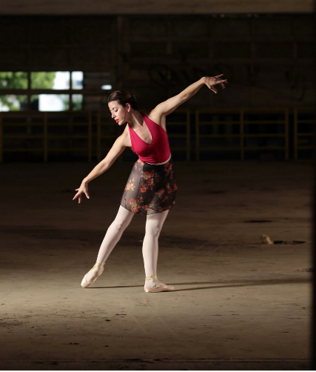
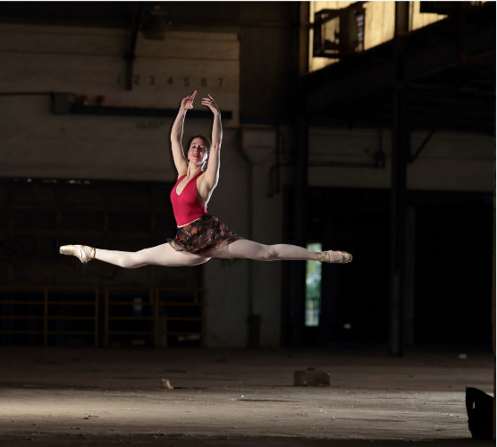
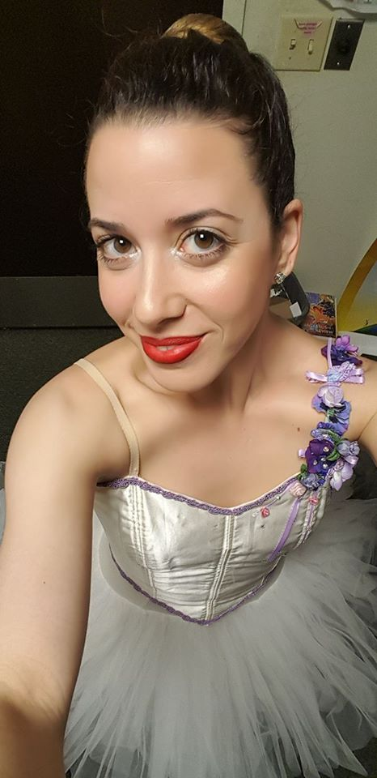

Alana Calhoun

Ballet and Pre-Pointe Dance Instructor

Originally from New York, Alana Calhoun has been instructing dance since 1999. She began teaching in Rochester, NY and earned her Dance Instructor Certification through Dance Masters of America in 2003. She has been the director of 6 ballet programs in addition to teaching tap, jazz, modern, hip hop, Israeli, and Broadway dance classes all over the country. Alana has choreographed for the Miss Deaf Texas pageant, college scholarship pieces, competition pieces, and has trained students who were accepted into competitive ballet summer intensives. Alana is also a professional ballet dancer and trained aerialist. She began dancing in New York City when she was 2 1/2 years old. She has danced in Washington, D.C. at the Washington Ballet Studio, Rochester, NY with the Draper Center for Dance and for Calabash, a Modern Dance Company, and in Miami, FL with the Kirova Ballet Company. Locally, she has danced with the San Antonio Metropolitan Ballet, and the Alamo Arts Ballet Theatre. Some of her favorite roles include Tarantella in La Boutique Fantasque, the Yellow and Diamond Fairies in Sleeping Beauty, the Red Queen in Alice, a Ballet Wonderland, and Spanish in The Nutcracker. Alana has a beautiful 11 month old daughter who she hopes will follow in her ballerina footsteps! She is thrilled to be back at Cynergy Dance Studio teaching for another wonderful season.

